# Assignment 4

**Title:**

1. Create a simple Mobile Website using jQuery Mobile.
2. Deploy/Host Your web application on AWS VPC or A

**Theory:**

# Part a

**jQuery Mobile**

JQuery Mobile is a user interface framework, built on jQuery Core and used for developing responsive websites or applications that are accessible on mobile, tablet, and desktop devices. It uses features of both jQuery and jQueryUI to provide API features for mobile web applications. This tutorial will teach you the basics of jQuery Mobile framework. We will also discuss some detailed concepts related to jQuery Mobile.

**Why Use jQuery Mobile?**

* It creates web applications that it will work the same way on the mobile, tablet, and desktop devices.
* It is compatible with other frameworks such as PhoneGap, Whitelight, etc.
* It provides a set of touch-friendly form inputs and UI widgets.

**Features of jQuery Mobile:**

* It is built on jQuery Core and "write less, do more" UI framework.

* It’s an open source framework, and cross-platform as well as cross-browser compatible.

* It is written in JavaScript and uses features of both jQuery and jQuery UI for building mobile-friendly sites.

**jQuery Mobile Setup:**

1. When you open the link https://jquerymobile.com/, under download section you will see 2. “Copy-and-Paste snippet for jQuery CDN” section.

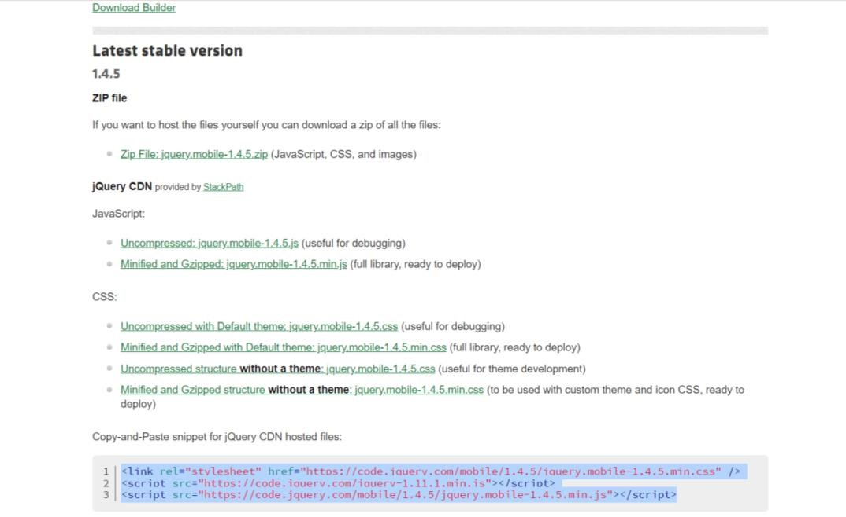

* 1. Copy the given snippet mentioned under “CDN hosted files” section.

* 1. Lastly paste, that copied snippet inside your <head> section of HTML document.

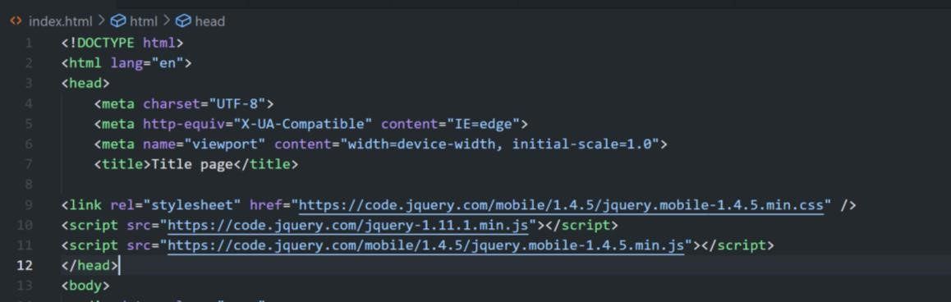

**jQuery components used in practical**

**jQuery Navbar :**

A navbar is coded as an unordered list of links wrapped in a container element that has the data-role="navbar" attribute. When a link in the navbar is clicked it gets the active (selected) state. The ui-btn-active class is first removed from all anchors in the navbar before it is added to the activated link. If this is a link to another page, the class will be removed again after the transition has completed.

To set an item to the active state, add class="ui-btn-active" to an anchor in the markup. Additionally add a class of ui-state-persist to make the framework restore the active state each time the page is shown while it exists in the DOM.

**jQuery Form elements:**

All form widgets begin with native form elements with rich HTML semantics that are enhanced to make them more attractive and finger-friendly.

When constructing forms to be used in jQuery Mobile, most of the standard guidelines used to create forms that submit via ordinary HTTP POST or GET still apply. Additionally, the id attributes of form controls need to be not only unique on a given page, but also unique across the pages in a site. This is because jQuery Mobile's singlepage navigation model allows many different "pages" to be present in the DOM at the same time. You must be careful to use unique id attributes so there will be only one of each in the DOM. Be sure to pair them properly with label elements via the for attribute.

**Conclusion:** Mobile website using jQuery is created successfully.